**The Random Graphics lab**

**Create a ClassUsage project. In this new project create two new classes:**

**RandomGraphics.java and RandomGraphicsDemo.java.**

For this lab assignment you are provided with a grid of two rows by two columns. Each cell in the grid needs some graphics object to be drawn. It will be necessary to construct objects of the **Random** and **Color** classes to complete this assignment. The use of the grid is intentional. For three cells you will need to display random graphics objects that must stay within the boundaries of the cell. This becomes a test of your knowledge about generating random values in the proper range. You will not get credit if the objects are drawn outside the cell boundaries.

|  |
| --- |
| **RandomGraphics.java** |
| import gpdraw.*;  import java.util.*;  public class RandomGraphics  {  private DrawingTool pen;    public RandomGraphics(SketchPad sp){  pen = new DrawingTool(sp);  }    public void drawGrid(){  pen.drawRect(730,500);  pen.up();  pen.move(365,0);  pen.down();  pen.setDirection(180);  pen.forward(730);  pen.up();  pen.move(0,-250);  pen.down();  pen.setDirection(90);  pen.forward(500);  }  } |

|  |
| --- |
| **RandomGraphicsDemo.java** |
| import gpdraw.*;  public class RandomGraphicsDemo  {  public static void main(String[] args){  SketchPad sp= new SketchPad(800,600);  RandomGraphics rg = new RandomGraphics(sp);  rg.drawGrid();  }  } |

At the beginning, RectangleGraphicsDemo.java creates the below grid.

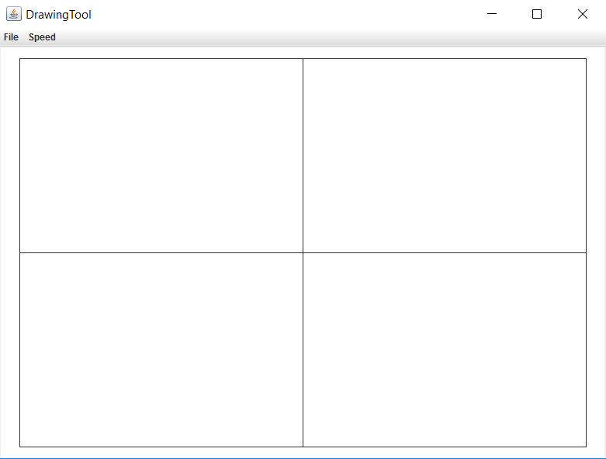

Each of the following in it’s own method!

1. The cell with lines displays 4 random lines.

Both ends of the line have random x and y coordinate locations.

1. The cell with rectangles displays 4 random rectangles.

The rectangles need to be drawn at random locations within the cell, and be entirely inside the cell.

The rectangles have random heights and widths with a maximum of 50 pixels.

1. The cell with circles displays 4 random circles.

The circles need to be drawn at random locations within the cell, and be entirely inside the cell.

The circles have a random diameter which ranges from 0 to 100 pixels.

1. The cell with the box uses nothing random.

It uses drawString() to write your name on one line and your class period on the next.

NOTE: YOU ARE REQUIRED TO USE **Math.random()** TO GENERATE ALL RANDOM VALUES!!!

**90 Point Version Output**

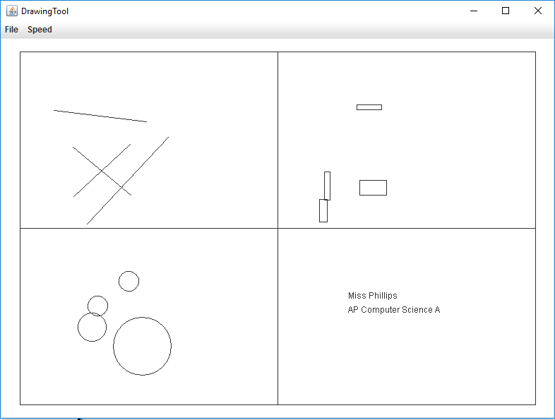

**100 Point Version Output**

